**Mini Project Progress - I Report**

**On**

**Study and Implementation of Five Factor Model**



***By:***

Md. Monirul Islam (Reg. No. 202000237)

Phirat Passi (Reg. No. 202000553)

Sourav Dutta (Reg. No. 202000402)

*In partial fulfillment of requirements for the award of degree in*

Bachelor of Technology in Computer Science and Engineering

(2023)

***Under the Project Guidance of:***

**Mrs. Minakshi Roy**

**Assistant Professor (SG)**

**DEPARTMENT OF COMPUTER SCIENCE AND ENGINEERING**

**SIKKIM MANIPAL INSTITUTE OF TECHNOLOGY**

(A constituent college of Sikkim Manipal University)

MAJITAR, RANGPO, EAST SIKKIM – 737136

CONTENTS

|  |  |  |
| --- | --- | --- |
| Sl.No | Title | Page No |
| 1 | Abstract | 3 |
| 2 | Introduction | 4-5 |
| 3 | Literature Survey | 6 |
| 4 | Problem Definition | 7 |
| 5 | Solution Strategy | 8 |
| 6 | Design | 9-10 |
| 7 | Implementation | 11 |
| 8 | Results | 12 |
| 9 | Gantt chart | 13 |
| 10 | References | 14 |

1. ABSTRACT

The purpose of this project is to explore the use of multiple personality determining models, including the Myers-Briggs Type Indicator (MBTI), Five Factor Model (FFM), and Big Five Inventory (BFI-10), to suggest a person's career path. The MBTI is a widely-used personality framework that categorizes individuals into one of 16 personality types based on their preferences for four dichotomies: extraversion/introversion, sensing/intuition, thinking/feeling, and judging/perceiving. The FFM, also known as the Big Five personality traits, categorizes personality traits into five dimensions: openness, conscientiousness, extraversion, agreeableness, and neuroticism. The BFI-10 is a brief version of the original Big Five Inventory and measures each of the five personality dimensions through 10 items.

By analysing an individual's personality traits, as assessed by the MBTI, FFM, and BFI-10, this project aims to suggest a career path that aligns with their personality characteristics. For example, an individual who scores high in extraversion, intuition, thinking, and judging on the MBTI may be suited for a career in engineering, while an individual who scores high in openness and agreeableness on the FFM may be suited for a career in social work.

However, it is important to note that personality traits are just one factor to consider when making career suggestions, and that other factors such as personal interests, values, and skills should also be taken into account. The overall goal of this project is to contribute to the critical data set for research on career prediction, which can help individuals make informed decisions about their future career paths.

1. INTRODUCTION

In today’s competitive world it is very difficult for students to understand their interests and find their suitable career. There are numerous fields to choose from. Choosing from this huge plethora of career options is a real challenge before the individuals today. To compete and reach the goals of the students it is very important for them to plan and organize from the initial stages of their lives. For this it is necessary to constantly evaluate their performance, identify interests and keep track of how close they are to their goals and also assess if they are on the right track towards their target.

Predictive analytics is a branch of advanced analytics that makes predictions about future outcome using historical data combined with statistical modelling, data mining techniques and machine learning. Nowadays predictive analytics is used in personality assessment of human’s behavioral traits.

The three prominent models like Five factor, Holland and MBTI are used for assessing a person’s qualitative attributes which leads to career prediction.

1. **Five Factor Model**

The Big Five personality traits is a suggested taxonomy, or grouping, for personality traits, developed from the 1980s onward in psychological trait theory.

* openness to experience (inventive/curious vs. consistent/cautious)
* conscientiousness (efficient/organized vs. extravagant/careless)
* extraversion (outgoing/energetic vs. solitary/reserved)
* agreeableness (friendly/compassionate vs. critical/rational)
* neuroticism (sensitive/nervous vs. resilient/confident)

Those labels for the five factors may be remembered using the acronyms "OCEAN" or "CANOE". Beneath each proposed global factor, there are a number of correlated and more specific primary factors. For example, extraversion is typically associated with qualities such as gregariousness, assertiveness, excitement-seeking, warmth, activity, and positive emotions. These traits are not black and white, but rather placed on continua.

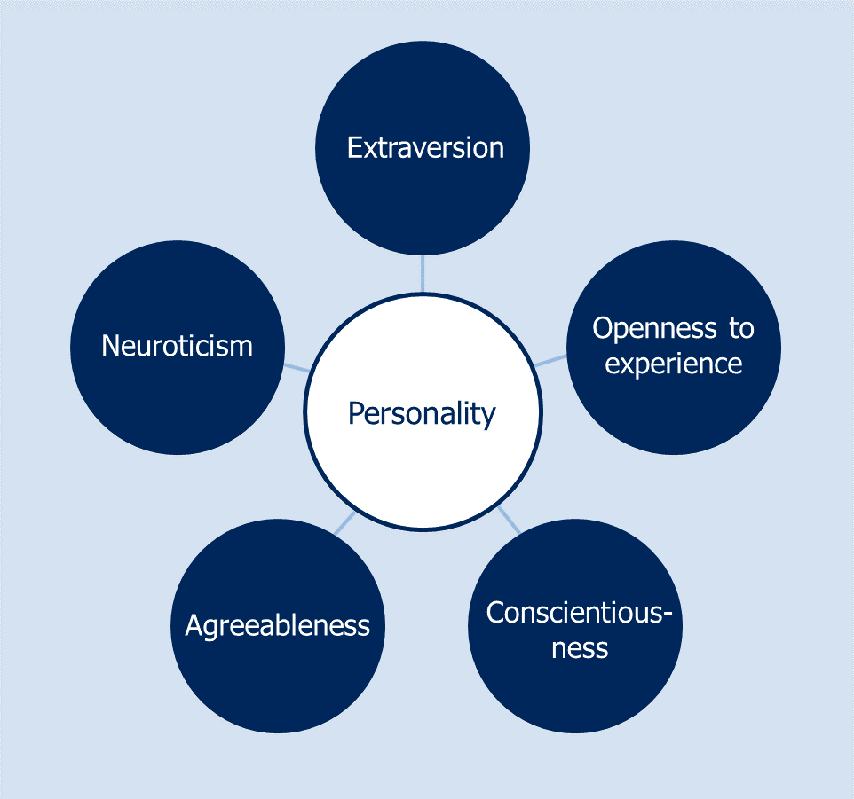

Fig-1: Five factor model

1. **MBTI Model:**

In personality typology, the Myers–Briggs Type Indicator (MBTI) is an introspective self-report questionnaire indicating differing psychological preferences in how people perceive the world and make decisions. Despite its popularity, it has been widely regarded as pseudoscience by the scientific community. The test attempts to assign a value to each of four categories: introversion or extraversion, sensing or intuition, thinking or feeling, and judging or perceiving.

* Extraversion (E) – Introversion (I)
* Sensing (S) – Intuition (N)
* Thinking (T) – Feeling (F)
* Judging (J) – Perceiving (P)

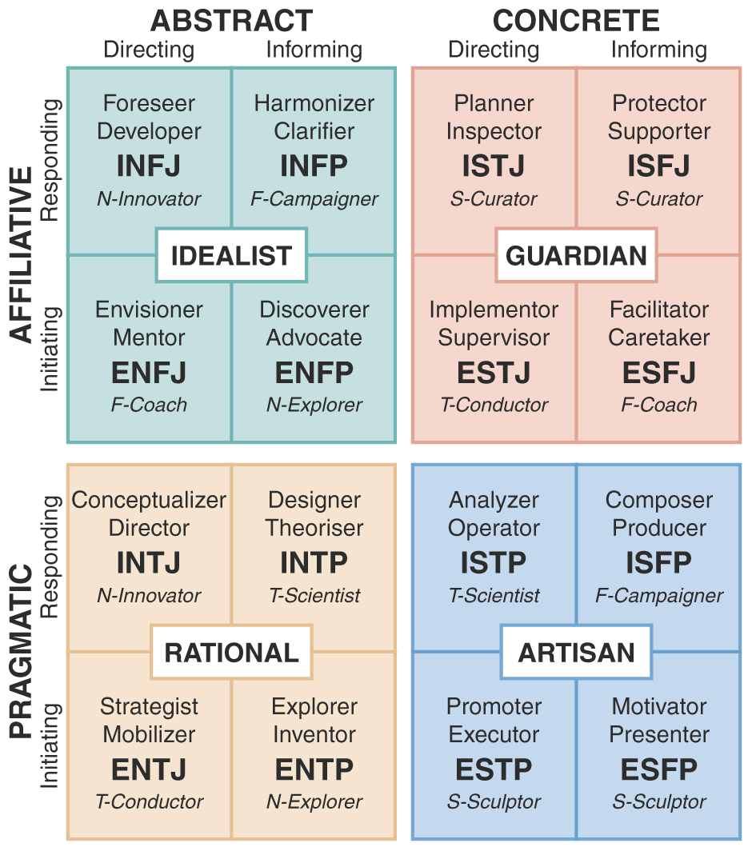

Fig-3: MBTI model

1. LITERATURE SURVEY

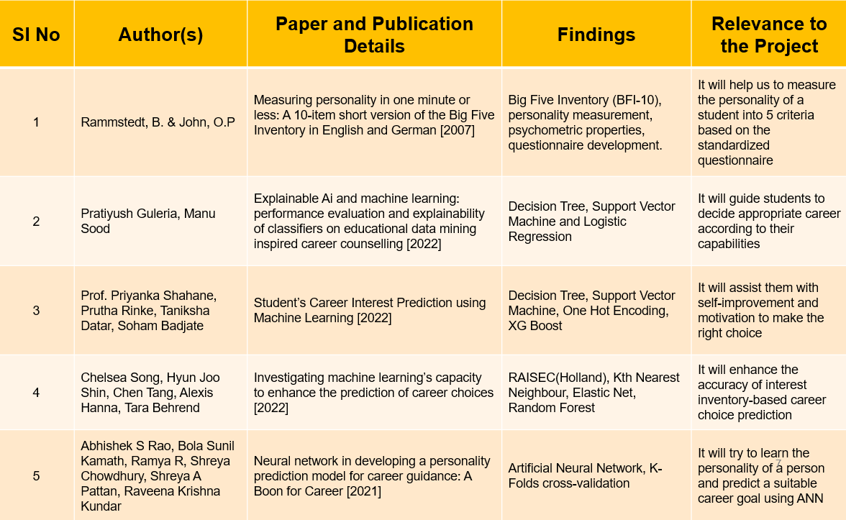

1. PROBLEM DEFINITION

* Currently various models are available for assessing a person’s behavioral traits (qualitative attributes), so it is tough to find the appropriate model which gives better accuracy.

* Choosing a career can be a quite daunting task for a learner as per their personality (behavioral traits)
* Career counselling is challenging task which is done by expert career counsellors, and we completely rely on their expertise. However, humans are prone to errors and biases.

1. SOLUTION STRATEGY

* **Data Collection:** It is the systematic approach to gathering and measuring information from a variety of sources to get a complete and accurate picture of an area of interest.
* **Data preprocessing:** It describes any type of processing performed on raw data to prepare it for another processing procedure.
* **Assessing the attributes:** It will qualitatively analyze the learner’s attributes.
* **Calculating personality score:** We use BFI-10 scoring to find the personality score.
* **Statistical Inference:** It helps us to make predictions from the data
* **Mapping personality to career:** We map the five factors of BFI-10 to the 16 personalities of the MBTI model which already has suggested career options.
* **Implementation of model:** Models such as Big Five and Big Five Inventory (BFI) are used.
* **Testing:** The trained model is tested against the remaining dataset.

6. DESIGN

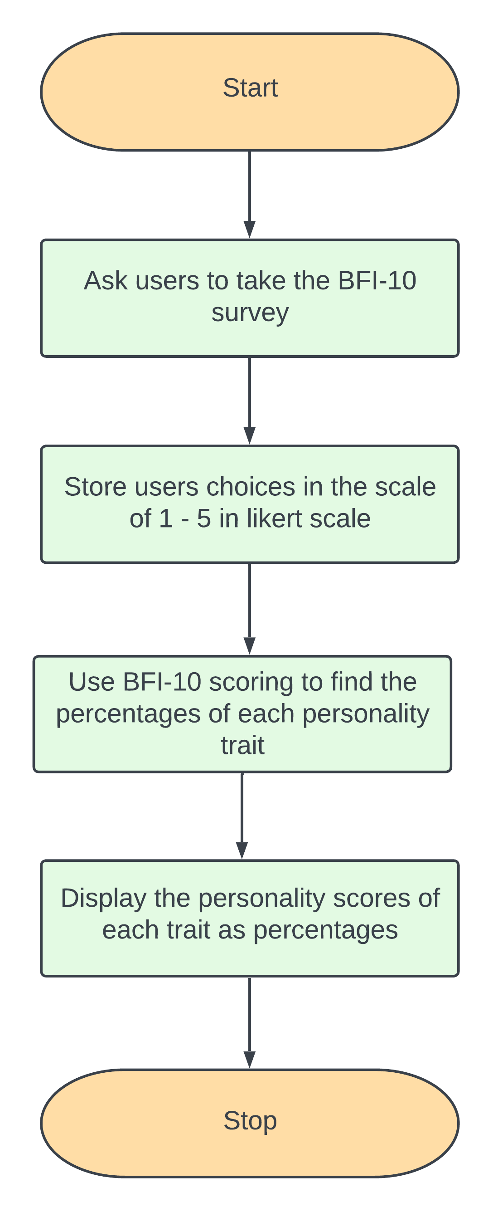

SYSTEM ARCHITECTURE

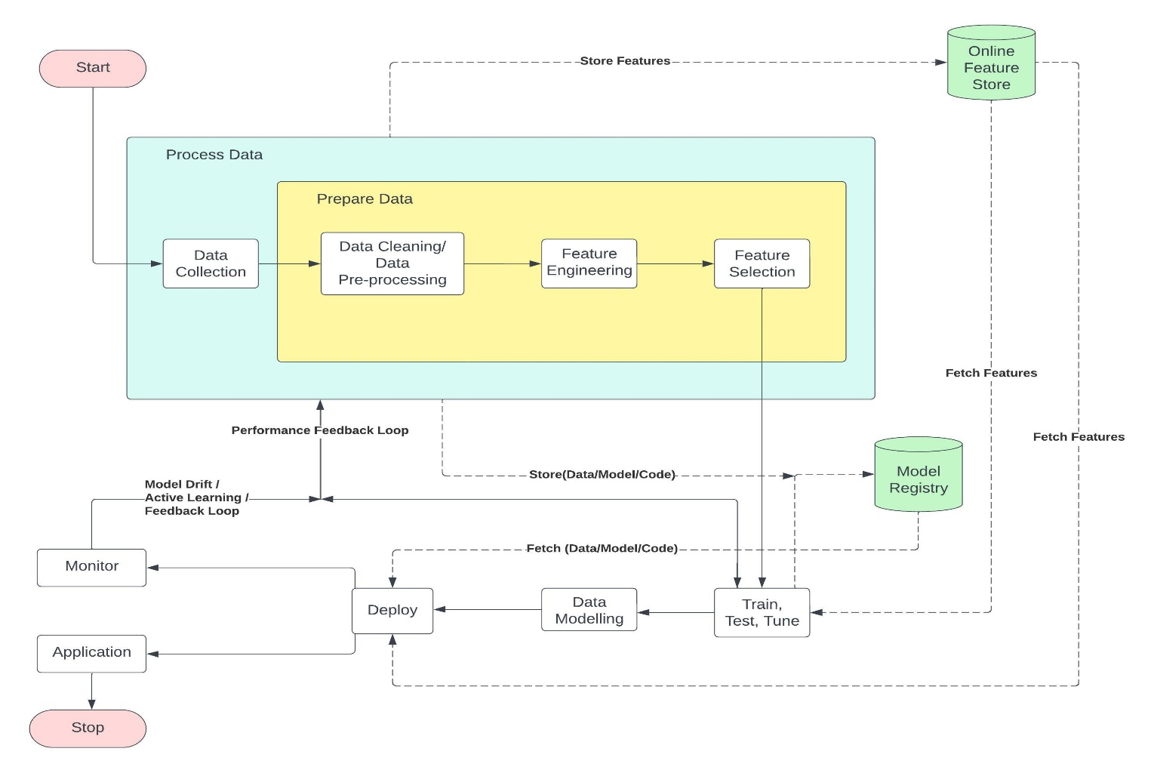

1. IMPLEMENTATION

**Algorithm:**

**Step 1:** Start

**Step 2:** We have chosen Big Five Inventory (BFI)-10 standardized questionnaire to assess user personality.

**Step 3:** We take the input from the user from the frontend through BFI-10 standardized questionnaire.

**Step 4:** We now calculate personality scores based on the input using the BFI-10 scoring.

**Step 5:** Display the personality score of the user.

**Step 6:** We now map the five personality scores onto the 16 personalities of Myers-Briggs Type Indicator (MBTI).

**Step 7:** We can now map MBTI personalities to respective careers.

**Step 8:** Stop.

Accomplished

To be Accomplished

1. RESULTS

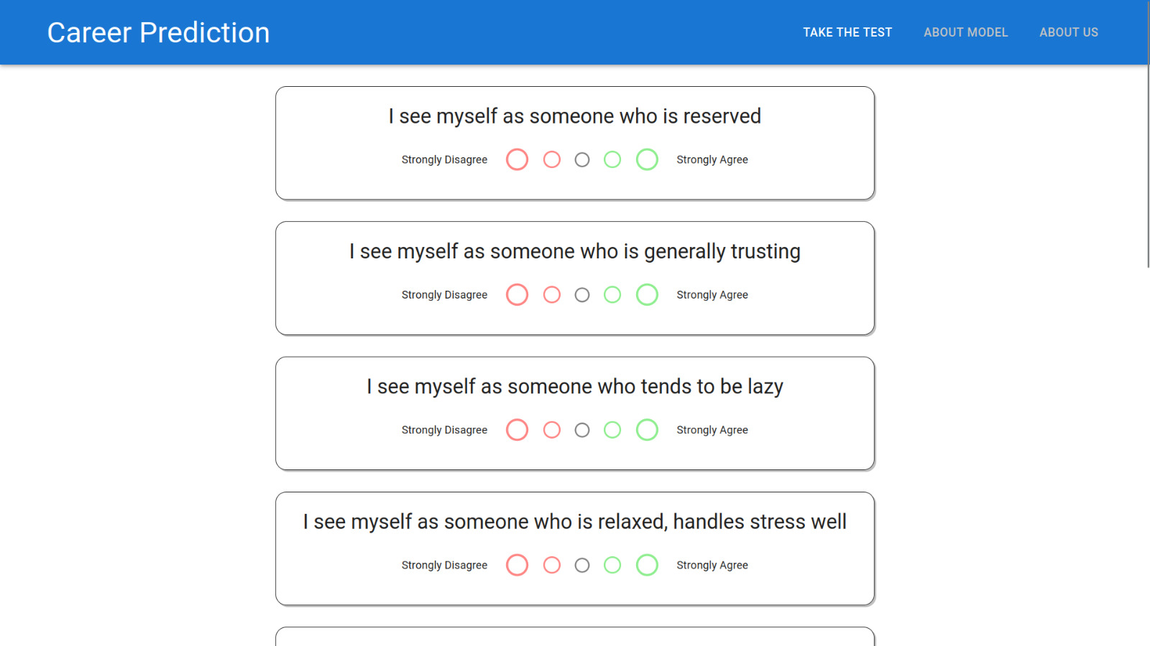

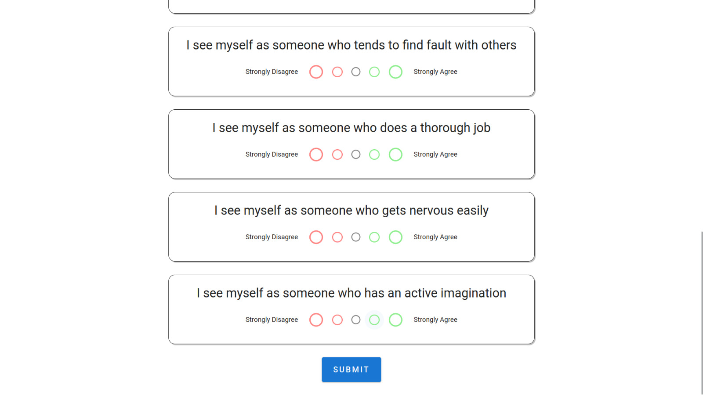

1. GANTT CHART

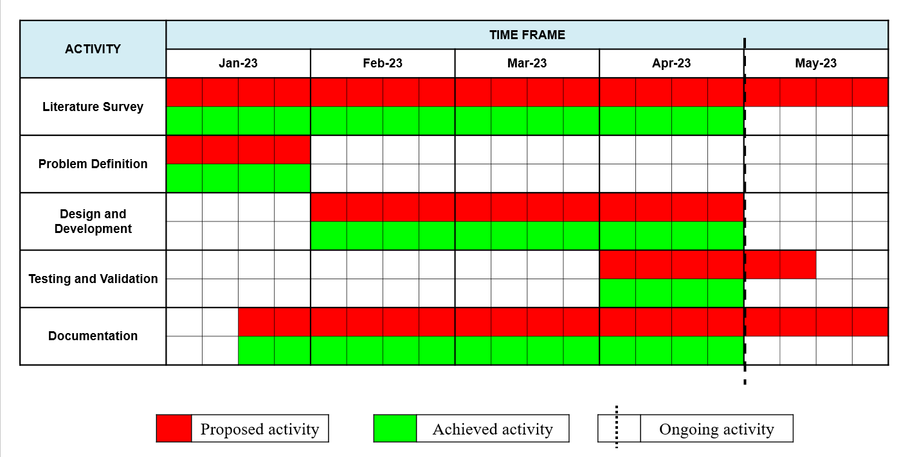

1. REFERENCES

[1] Chaudhary, Dileep, et al. "Student future prediction using machine learning." International Journal of Scientific Research in Computer Science, Engineering and Information Technology 5.2 (2019): 2456-3307.

[2] Guleria, Pratiyush, and Manu Sood. "Explainable AI and machine learning: performance evaluation and explainability of classifiers on educational data mining inspired career counseling." Education and Information Technologies (2022): 1-36.

[3] Khan, Mohd Sahid, and Manuj Darbari. "Myers-Briggs Type Indicator and Social Media Mining Based Career Counselling System." Partners Universal International Research Journal 1.2 (2022): 35-42.

[4] Rammstedt, B. & John, O.P. (2007). Measuring personality in one minute or less: A 10-item short version of the Big Five Inventory in English and German. Journal of Research in Personality, 41, 203–212.

[5] Rao, Abhishek S., et al. "Use of artificial neural network in developing a personality prediction model for career guidance: A boon for career counselors." International Journal of Control and Automation 13.4 (2020): 391-400.

[6] Song, Q. Chelsea, et al. "Investigating machine learning's capacity to enhance the prediction of career choices." Personnel Psychology (2022).

THANK YOU!